CIS 452

Lab 10 Report

Ashley Hendrickson

Muna Gigowski

Fall 2019

Windows Memory Management

1. What is the total amount of Physical Memory (KB) on your system (In use + Available)?

In use: 4.9 GB

Available: 3GB

Total: 7.9 GB

2. Based on observed changes to the amount of Available memory, what is the apparent memory footprint (i.e. the full memory demand) of MS IE, with several web pages open?

Before opening IE: 4.8 GB available

After opening IE with 3 web pages: 4.2 GB available

IE Memory Footprint (with 3 web pages open): .6 GB

3. Note the changes in the reported amount of Available memory as graphed in the display and in the details reported below. Again, shut down the browsers (one at a time). Why is the apparent memory footprint of two instances of Internet Explorer not exactly twice the memory usage of a single instance?

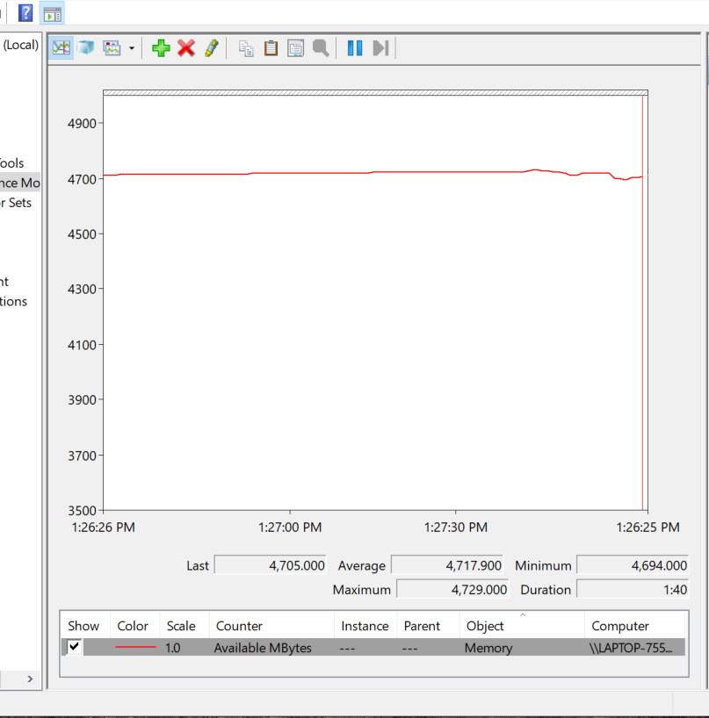**Before Opening any Sessions**:

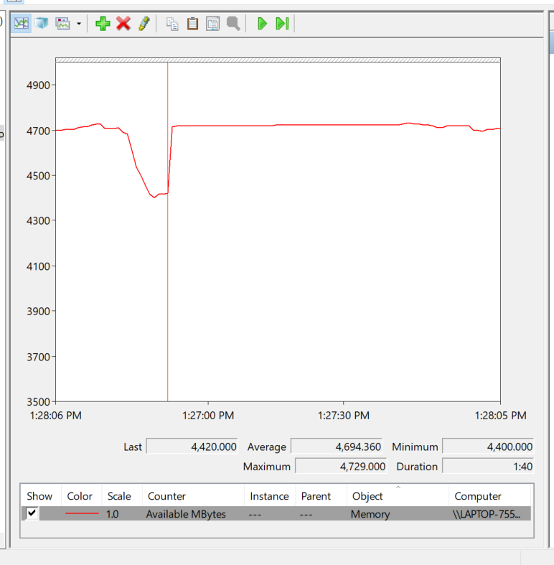**After Opening One Session**:

**After opening Two Sessions:**

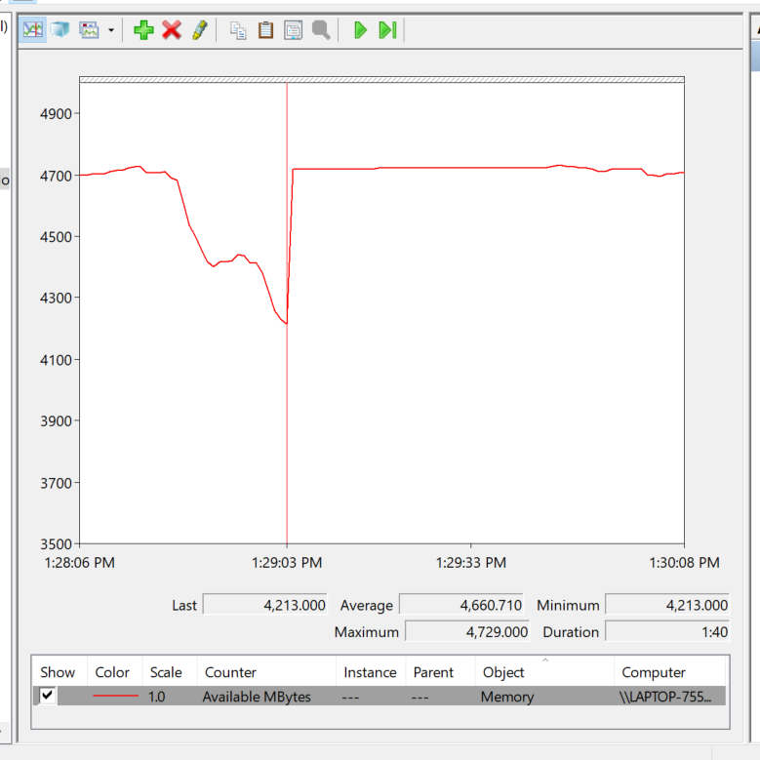

**After Closing One Session:**

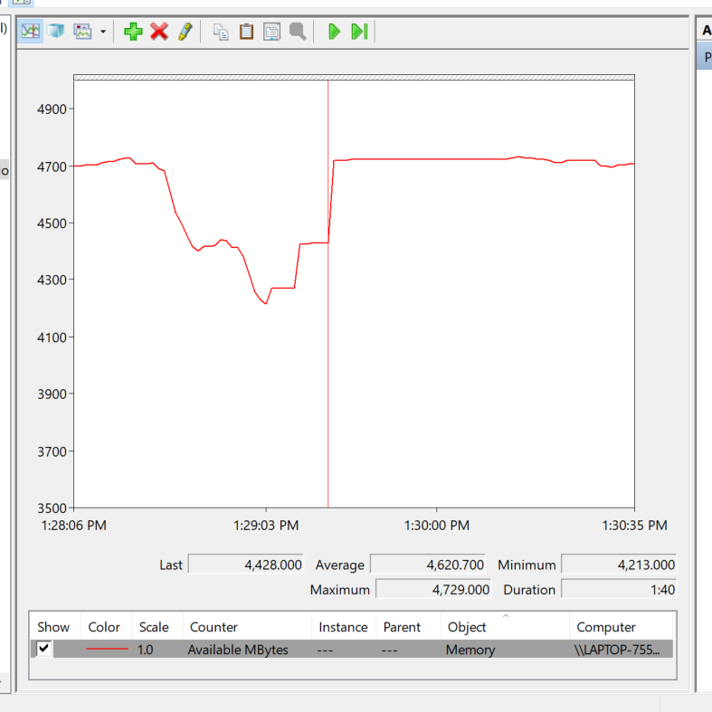

**After Closing Both Sessions:**

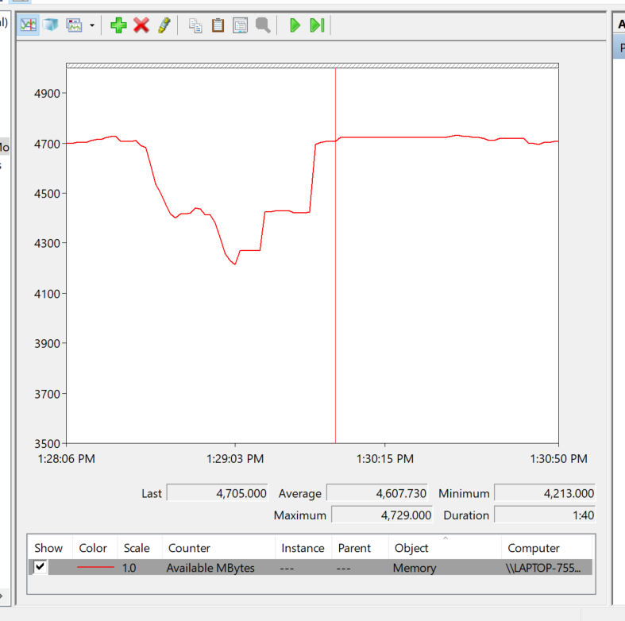

The apparent memory footprint of two instances of Internet Explorer is not exactly twice the memory usage of a single instance (the second instance used roughly 2/3 the amount of memory that the first instance did) because the two browser sessions share certain data (such as cookies, read-only files, etc.).

4. How much physical memory is Wordpad using?

Wordpad is using 45,144 KB of physical memory, which we found by looking at the “Working Set” column for the row that belonged to the Wordpad process.

[Extra Credit] Programming Assignment (Memory Management Functions)